ABOUT SULAWESI
Basic information about sualwesi https://en.m.wikipedia.org/wiki/Sulawesi

Sulawesi
"Celebes" redirects here. For the painting by Max Ernst, see The Elephant Celebes.Sulawesi, formerly known as Celebes (/ˈsɛlᵻbiːz/ or /sᵻˈliːbiːz/), is an island in Indonesia. One of the four Greater Sunda Islands, and the world's eleventh-largest island, it is situated east of Borneo, west of the Maluku Islands, and south of Mindanao and the Sulu Archipelago. Within Indonesia, only Sumatra, Borneo and Papua are larger in territory, and only Java and Sumatra have larger population.
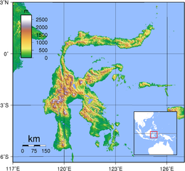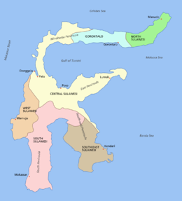
Geography
Demographics
Population | 18,455,058 (2014 estimate)
Pop. density | 105.7 /km² (273.8 /sq mi)
Ethnic groups | Makassarese, Buginese, Mandar, Minahasa, Gorontalo, Toraja, Butonese, Bajau, Mongondow
Flag of Sulawesi

Location | South East Asia
Coordinates | 02°S 121°E
Archipelago | Greater Sunda Islands
Area | 180,680.7 km² (69,761.2 sq mi)
Area rank | 11th
Highest elevation | 3,478 m (11,411 ft)
Highest point | Rantemario
Administration
Indonesia
Provinces  (capital) | - West Sulawesi (Mamuju)  - North Sulawesi (Manado)  - Central Sulawesi (Palu)  - South Sulawesi (Makassar)  - South East Sulawesi (Kendari)  - Gorontalo (Gorontalo)
Largest settlement | Makassar (pop. 1,338,633)

Etymology
The name Sulawesi possibly comes from the words sula ("island") and besi ("iron") and may refer to the historical export of iron from the rich Lake Matano iron deposits.^{[1]} The term "sula" also means tines, horn or spikes, derived from Sanskrit, as trishula refer to "trident". Thus "sulawesi" means "iron spikes", which suggested that the island was also a producer of iron edged weapons. The name came into common use in English following Indonesian independence.
The name Celebes was originally given to the island by Portuguese explorers. It is widely considered a Portuguese rendering of the native name "Sulawesi".^{[citation needed]}

Geography
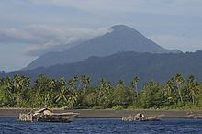
Mount Tongkoko is a volcano in North Sulawesi
Sulawesi is the world's eleventh-largest island, covering an area of 174,600 km² (67,413 sq mi). The central part of the island is ruggedly mountainous, such that the island's peninsulas have traditionally been remote from each other, with better connections by sea than by road. The three bays that divide Sulawesi's peninsulas are, from north to south, the Tomini, the Tolo and the Boni.^{[n 1]} These separate the Minahassa or Northern Peninsula, the East Peninsula, the Southeast Peninsula and the South Peninsula.
The Strait of Makassar runs along the western side of the island.^{[citation needed]} The island is surrounded by Borneo to the west, by the Philippines to the north, by Maluku to the east, and by Flores and Timor to the south.

Minor islands
The Selayar Islands make up a peninsula stretching southwards from Southwest Sulawesi into the Flores Sea are administratively part of Sulawesi. The Sangihe Islands and Talaud Islands stretch northward from the northeastern tip of Sulawesi, while Buton Island and its neighbours lie off its southeast peninsula, the Togian Islands are in the Gulf of Tomini, and Peleng Island and Banggai Islands form a cluster between Sulawesi and Maluku. All the above-mentioned islands, and many smaller ones, are administratively part of Sulawesi's six provinces.

Geology
The island slopes up from the shores of the deep seas surrounding the island to a high, mostly non-volcanic, mountainous interior. Active volcanoes are found in the northern Minahassa Peninsula, stretching north to the Sangihe Islands. The northern peninsula contains several active volcanoes such as Mount Lokon, Mount Awu, Soputan and Karangetang.
According to plate reconstructions, the island is believed to have been formed by the collision of terranes from the Asian Plate (forming the west and southwest) and from the Australian Plate (forming the southeast and Banggai), with island arcs previously in the Pacific (forming the north and east peninsulas).^{[5]} Because of its several tectonic origin, faults scar the land; as a result, the island is prone to earthquakes.
Sulawesi, in contrast to most of the other islands in the biogeographical region of Wallacea, is not truly oceanic, but a composite island at the centre of the Asia-Australia collision zone.^{[6]} Parts of the island were formerly attached to either the Asian or Australian continental margin and became separated from these areas by vicariant processes.^{[6]} In the west, the opening of the Makassar Strait separated West Sulawesi from Sundaland in the Eocene c. 45 Mya.^{[6]} In the east, the traditional view of collisions of multiple micro-continental fragments sliced from New Guinea with an active volcanic margin in West Sulawesi at different times since the Early Miocene c. 20 Mya has recently been replaced by the hypothesis that extensional fragmentation has followed a single Miocene collision of West Sulawesi with the Sula Spur, the western end of an ancient folded belt of Variscan origin in the Late Paleozoic.^{[6]}

History
'Padjogé' dancers in Maros, Sulawesi, in the 1870s
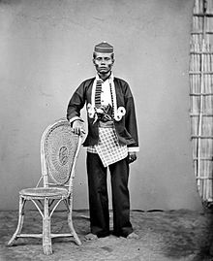
Local chief (1872)
Starting in the 13th century, access to prestige trade goods and to sources of iron started to alter long-standing cultural patterns, and to permit ambitious individuals to build larger political units. It is not known why these two ingredients appeared together; one was perhaps the product of the other.
In 1367, several polities, identified was located on the island, was mentioned in Javanese manuscript Nagarakretagama dated from Majapahit period. The canto 14 mentioned polities including Gowa, Makassar, Luwu and Banggai. It seems by 14th century, polities in the island was connected in an archipelagic maritime trading network centered in Majapahit port in East Java. By 1400, a number of nascent agricultural principalities had arisen in the western Cenrana valley, as well as on the south coast and on the west coast near modern Parepare.^{[17]}
The first Europeans to visit the island (which they believed to be an archipelago due to its contorted shape) were the Portuguese sailors Simão de Abreu, in 1523, and Gomes de Sequeira (among others) in 1525, sent from the Moluccas in search of gold, which the islands had the reputation of producing.^{[18][19]} A Portuguese base was installed in Makassar in the first decades of the 16th century, lasting until 1665, when it was taken by the Dutch. The Dutch had arrived in Sulawesi in 1605 and were quickly followed by the English, who established a factory in Makassar.^{[20]} From 1660, the Dutch were at war with Gowa, the major Makasar west coast power. In 1669, Admiral Speelman forced the ruler, Sultan Hasanuddin, to sign the Treaty of Bongaya, which handed control of trade to the Dutch East India Company. The Dutch were aided in their conquest by the Bugis warlord Arung Palakka, ruler of the Bugis kingdom of Bone. The Dutch built a fort at Ujung Pandang, while Arung Palakka became the regional overlord and Bone the dominant kingdom. Political and cultural development seems to have slowed as a result of the status quo.
In 1905 the entire island became part of the Dutch state colony of the Netherlands East Indies until Japanese occupation in the Second World War. During the Indonesian National Revolution, the Dutch Captain 'Turk' Westerling led campaigns in which hundreds, maybe thousands died during the South Sulawesi Campaign.^{[21]} Following the transfer of sovereignty in December 1949, Sulawesi became part of the federal United States of Indonesia, which in 1950 became absorbed into the unitary Republic of Indonesia.^{[22]}

