Research- Pixie Dust
Definition:

pixie dust

noun
- A substance or influence with an apparently magical effect that brings great success or luck.
‘the folks who live there still seem to believe that they've been sprinkled with pixie dust’

Origin
1950s: from the magic dust that enabled humans to fly in J. M. Barrie's Peter Pan
- (fantasy) Magical dust associated with pixies; fairy dust.
- (figuratively) Any undefined means of working magic, in a metaphorical sense.

Pixie Dust is a magical golden glitter-like powder that grants the abilities of flight. Many think that flight is fueled by "happy thoughts", and this idea has been used in the Peter Pan movies and Hook, but in reality Peter Pan was actually joking with Wendy, John, and Michael Darling when he told them to think happy thought

Description
There are two types of dust. From the movies, "pixie dust" flows from the heart of the Pixie Dust Tree. From the books, following the Pixie Dust Tree's destruction, "fairy dust" is created by grinding the molten features of Mother Dove. In its common appearance, Pixie Dust is nothing more than a golden, sparkling powder. This dust comes from special blue pixie dust which replenishes the supply. As a golden color, it enables pixies to fly. Blue dust is shown to be a powerful augment and rejuvenator. However, there are also other colors of pixie dust revealed/created in the movies, such as green, pink, orange, teal, yellow, and purple, each granting a fairy a talent or augmenting one. If a fairy's wings get wet, pixie dust cannot replenish them until they are dry.

source: [online] https://en.oxforddictionaries.com/definition/us/pixie_dust
http://disney.wikia.com/wiki/Pixie_Dust

Appearances

Peter Pan
Originally shown in Peter Pan, Pixie dust apparently comes from the fairy Tinker Bell through her wings. It allows Peter's friends to fly away from London.
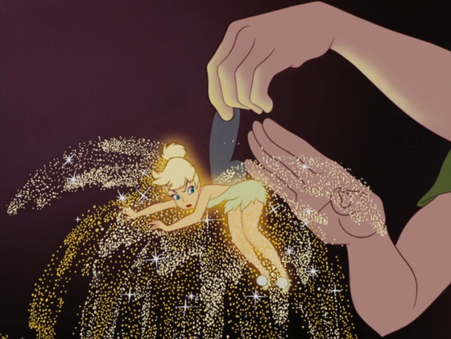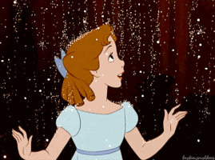

Tinker Bell
Blue Pixie Dust falling.
In the Disney Fairies franchise, it is shown to come from a reservoir in Pixie Hollow and evenly portioned out to every fairy in Never Land by the Dust-Talent fairy, Terence. Not only that, but Pixie Dust is needed for every Fairy to be able to fly and use their magic.
In Never Land, every eight years, when the moon turns blue, is a celebration called the Autumn Revelry, during which a Fairy is chosen from a Guild to create a scepter, which will hold the Moonstone, which, when the blue moon shines its light through the moonstone, creates blue Pixie Dust, which also rejuvenates the pixie dust tree.
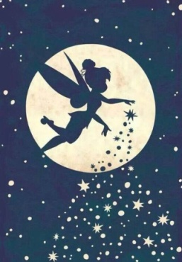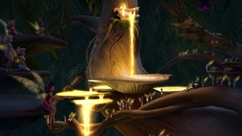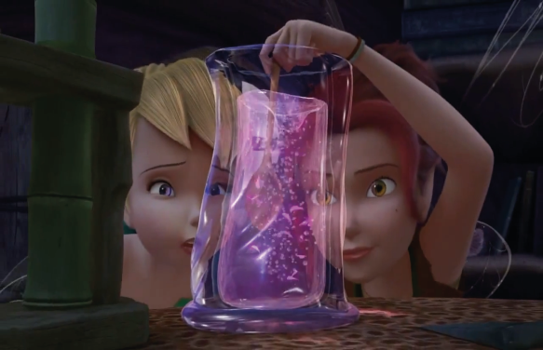
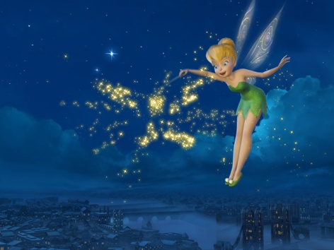

Once Upon a Time
A greatly more powerful version of Fairy Dust. It is capable of granting flight to the user if they believe, and the ability to find a soulmate for a person in need of love. David Nolan once described the potenecy as "nuclear fairy dust."
It can either be highly refined from Fairy Dust, or retrieved from the trees of Neverland. When Pan's youth was close to expiring, the trees no longer had any Pixie Dust; likely his breaking of Neverland's rules of only visiting in dreams caused too much strain on the world to continue production of it.
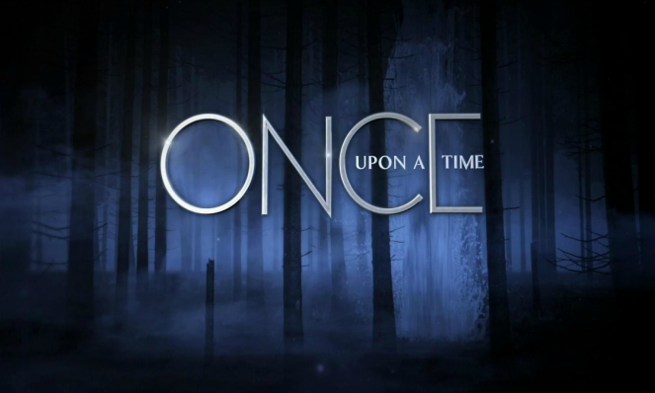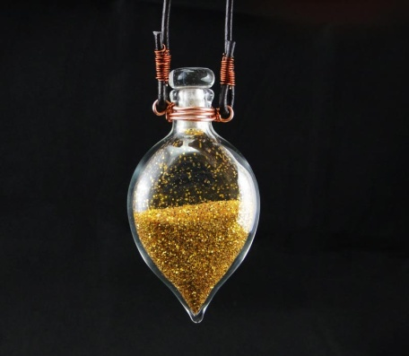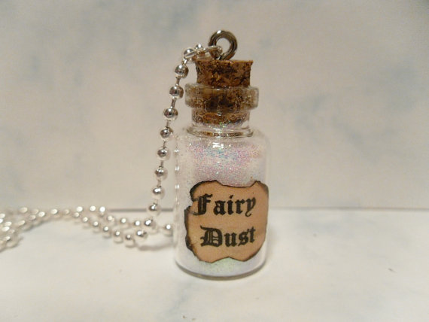

Jake and the Never Land Pirates
In Jake and the Never Land Pirates, Peter Pan ask the fairies to bestow Izzy with a small pouch of Pixie dust which is used in emergencies only, however she did have to use it one time when her crew (Jake, Skully, and Cubby) lost Bucky in a race against Captain Hook. In the episode "Pixie Dust Away!", Izzy loses all her pixie dust in the Never Sea. The Fairies inform Izzy and the other young pirates that they can restore their supply by visiting the Fountain of Forever which produces Pixie dust all year round.

The Pirate Fairy
In The Pirate Fairy, both the golden-yellow and blue pixie dust can be merged together with the help of a special ingredient to make various colors of pixie dust; each possessing its very own magical properties. Zarina uses the variously colored experimented pixie dust to switch Tinker Bell and her friends' talents.
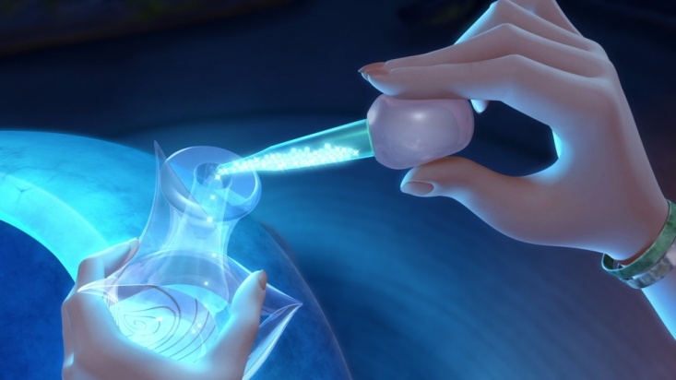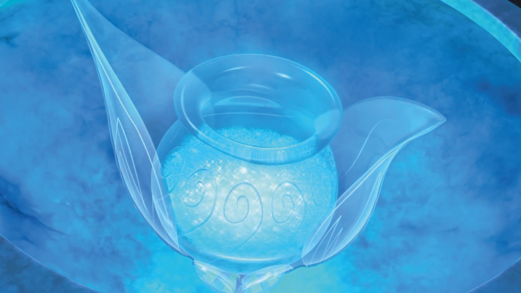ss

Pixie dust and abilities
BLUE: Creates golden pixie dust.Replenishes Gold Pixie Dust supply.Supremely powerful multiplier.
Creates other colors of pixie dust when mixed together with Gold Pixie Dust & certain ingredients.
GOLD: Grants Flight and/or Weightlessness.
Helps a fairy greatly argument and strengthen his or her magical talents.
GREEN: Grants the intellectual and intuitive abilities of a Tinker-Talent Fairy.
Restores a Tinker-Talent Fairy's lost/swapped out abilities.
Augments a Tinker-Talent Fairy's abilities onto a Non-Tinker-Talent Fairy.
AMBER: Grants the abilities of a Light-Talent Fairy.
Restores a Light-Talent Fairy's lost/swapped out abilities
PINK: Grants the abilities of a Garden-Talent Fairy.
Restores a Garden-Talent Fairy's lost/swapped out.
Augments a Garden-Talent Fairy's abilities onto a Non-Garden-Talent Fairy.
PURPLE: Grants the abilities of a Fast-Flying-Talent Fairy.
Restores a Fast-Flying-Talent Fairy's lost/swapped out abilities.
Greatly augments and magnifies a Fast-Flying-Talent Fairy's abilities onto a Non-Fast-Flying Fairy.
CYAN: Grants the abilities of a Water-Talent Fairy.
Restores a Water-Talent Fairy's lost/swapped out abilities.
ORANG: Grants the abilities of an Animal-Talent Fairy.
Restores an Animal-Talent Fairy's lost/swapped out abilities.
WHITE: Grants the abilities of a Frost-Talent Fairy.
Restores a Frost-Talent Fairy's lost/swapped out abilities.
GREY: Grants the abilities of a the abilities of a Storm-Talent Fairy.
Restores a Storm-Talent Fairy's lost/swapped out abilities.

OVERALL:
People believe pixie dust is magical dust granting success and luck, sprinkle the mind with happy thoughts

